Paper Title

Peter Jones1, Antony Smith1, Dong Liu2*, Xiaosan Zhang3

1 Introduction

This file is not only a template, but also a guide for submitting abstract. The abstract must be two pages long and in English. Please use this template, otherwise, your abstract will not be included in the proceedings.

Your abstract must include a title, one or a list of authors. The affiliation of authors appear at the end of the abstract.

2 Text and equations

This template file contains information on formatting. Please make sure that you do NOT change the formatting (fonts, margins, etc.) in any way for this is the format for the proceedings. Once you have completed your abstract, save/print/export to a PDF file and then submit it. Only submission in PDF format is accepted. Any non-compliant papers will be returned to the submitting authors and may be rejected. Since the symposium is run by volunteers, please do value their time spent on adjusting incorrectly formatted submissions.

2.1 Equations

The abstract can contain equations and figures. The equation numbering is optional, but if equations are numbered, they can be cross-referenced. For example, the cross-product of vector **r** with vector **F**.

**M** = **r** × **F** (1)

Then you can refer it as Eqn. (1) in your text.

If you have two aligned equations, but with a single equation number, you can show them as follows.

 (2)

Alternatively, each equation has its own number (Equations 3 and 4).

 (3)

**F** = *m***a** (4)

2.2 Theorem

If you have theorems, please use the following format.

**Theorem 1.** *Theorem text goes here.*

*Proof.* Proof text goes here.

3 Figures and tables

3.1 Figures

Figures should be high resolution bitmaps (300dpi or higher) or as vector graphics. For photographs, use .jpg files; for line drawings or sketches, use the .png format as.jpg files will make the lines blurry.

Coloured figures will appear in colour in the electronic version of the proceedings, but black and white in print. Please make sure that all figures are legible in greyscale.

3.2 Tables

Tables should align to the centre. Caption of a table must appear at the top of the table and aligned to centre.

Table 1: A simple table.

|  |  |  |
| --- | --- | --- |
| fruit | apples | pears |
| Vegetables | cauliflower | courgette |

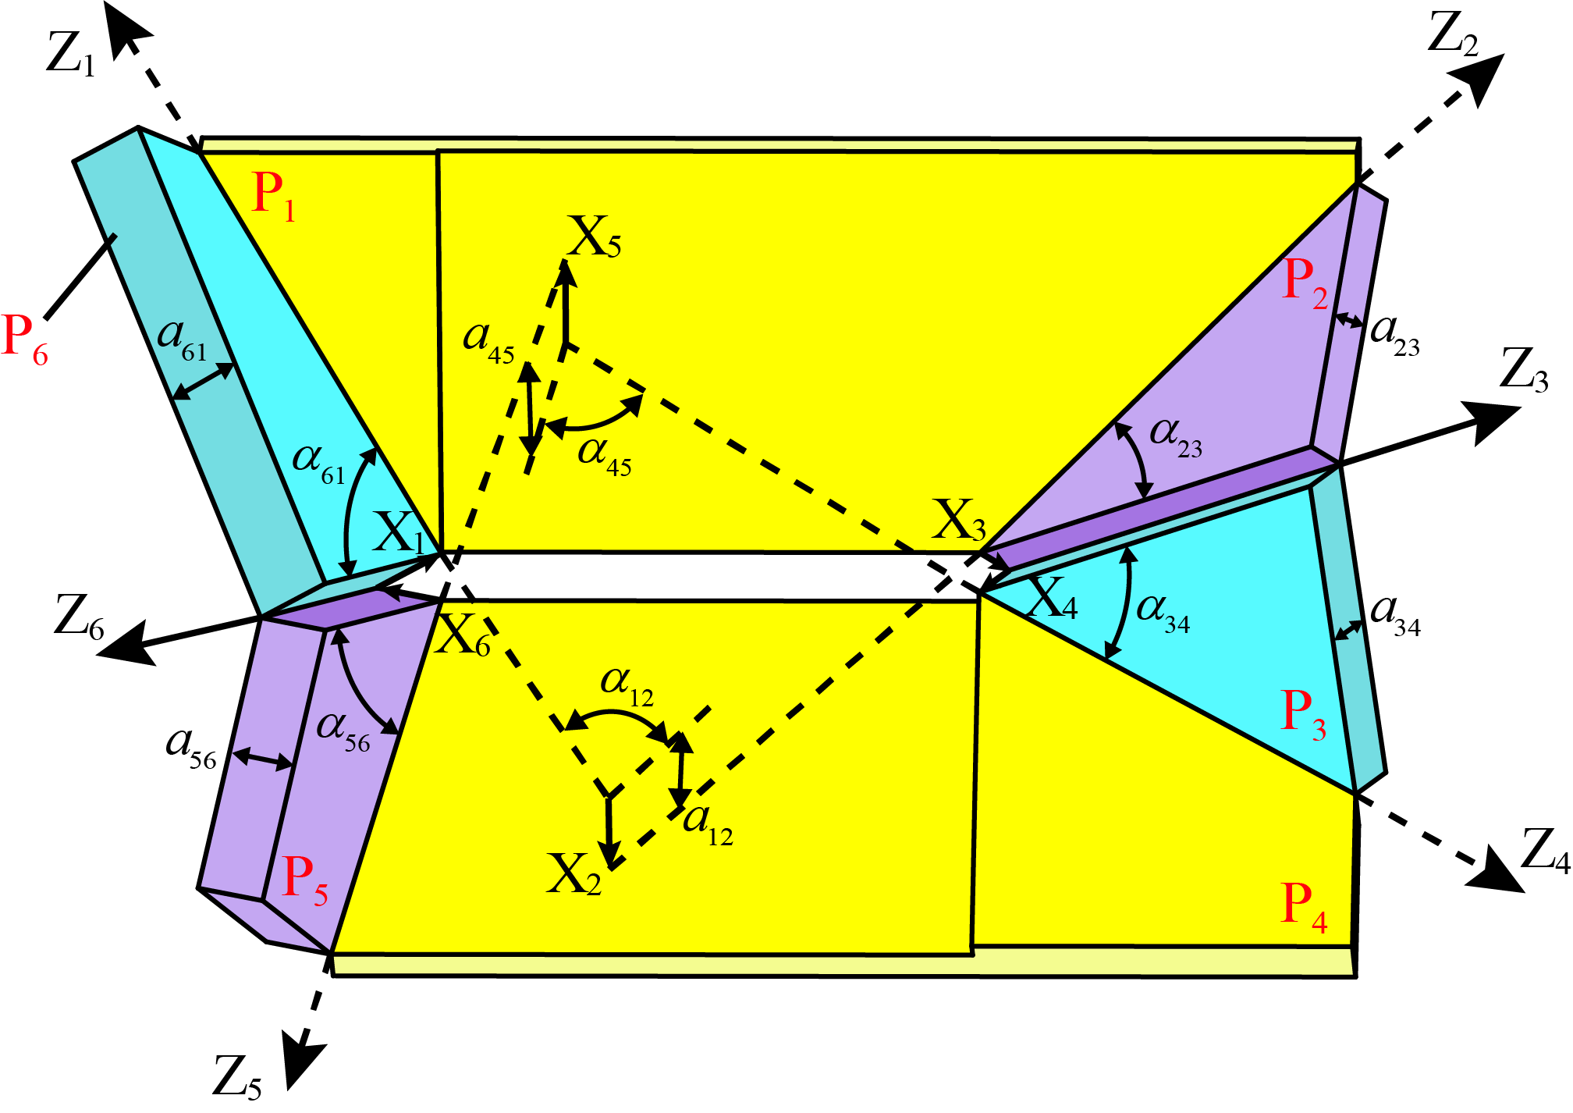

**Fig. 1:** The caption provides a brief description of the figure. It must be in italic and formatted as shown here. Please make sure that figure is aligned to centre. Letters and numbers in the figure must be readable.

 

(a) (b)

**Fig. 2:** You may also have two sub-figures as shown here, where both (a) and (b) must appear at the centre of each sub-figure.

4 List of items

A list of items can use numbered points:

1. item one
2. sub-item 1
3. sub-item 2

5 Citing references

A few references could be included using the format below. References to literature can be cited individually [Smith and Doe 17] or multiple citations can be combined [Wang-Iverson et al. 11, Miura et al. 2015].

References

[Miura et al. 15] Koryo Miura, Toshikazu Kawasaki, Tomohiro Tachi, Ryuhei Uehara, Robert J. Lang, and Patsy Wang-Iverson, editors. Origami 6, I: Mathematics. Ameri-can Mathematical Society, 2015.

[Smith and Doe 17] John Smith and Jane Doe. “A Very Interesting Article.” Journal of Interesting Topics 5:1 (2017), 10–15.

[Wang-Iverson et al. 11] Patsy Wang-Iverson, Robert J. Lang; and Mark Yim, editors. Origami 5: Fifth International Meeting of Origami Science, Mathematics, and Education. A K Peters/CRC Press, 2011. doi:10.1201/b10971.

1, 3 Name of Institute of the first and second author. e-mail: name@email.address

2* School of Mechanical Engineering, University of Nowhere. [name@email.address](mailto:name@email.address). (Corresponding author)